**1970**

#5 is born! He likes his green wall best. Dad is not terminated, but other people are. We almost take a trip to San Francisco. There are piano lessons, oboe lessons, and baseball practices. Recitals, band concerts, and baseball games. Movies and bowling and Howard Johnson’s. Birthday parties and snow days and endless church. Mom stops directing all the children’s choirs, and starts singing with the Chansonettes. Lisa gets a dollhouse and her very own room, Lesle’s costumes win all the awards. Andy puts on weight. Alan fields better than he hits. Dad slides down a really big slide.

**1-4-70 – Sun 8:40 PM -** Dear Mother, Aunt Clara, M.J. & Bill, The kids are about ready for bed since they have to get up for school in the morning – the vacation is over. Their piano lessons start again tomorrow, also. Thanks to everyone for everything while on our trip; we were all very glad that we went. As M.J. & Bill probably told you we came back on the non-reserved seat train (#24 – I think they plan to take it off in May if they can) rather than the San Francisco Chief, which was posted for 11:00 AM after I called you. They said it had been stalled for awhile in the snow in Texas, so we figured it would probably reach Newton even later than 11:00 AM. The other train (which goes through Hutch and we, of course, could have gotten on there) was not very late so we didn’t have to wait much longer. We checked the big bags (could not check the doll house since it wasn’t in a box) so just had the doll house to carry on besides the kids little things. The train was crowded and we finally got seats together by K City. Some people had to stand up and we crowded together part of the time to let a couple of women sit. At later stops as Kansas City people who had Chief reservations, like we did, were trying to get on; they didn’t let them all on at Kansas City. I’ve sent in for the $9.00 seat charge which we had paid for the reserved seats.

Our car started OK after sitting outdoors for 4 days. There had not been any more snow here so we drove home without any trouble on dry roads. The rats’ water bottle was almost empty, but they were OK. Inky was glad to see us; the neighbors had fed him. The boys say “Thank you” for the cards and gifts. For their parties we took them all (Ruth for Andy’s and I took Alan’s) to a movie. They all have so many new toys and things I don’t know where they’ll put everything.

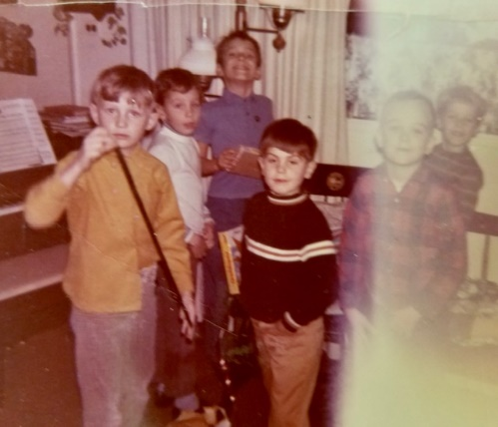

January 1 – Alan’s 9th birthday party. So many familiar faces.

Mr. L called last night and said Mrs. L spilled a cup of hot coffee on her front New Years Day, and had to go to the hospital – she’s getting along OK. I went to work Tues and Wed – I went in awhile Fri to help make up for Mon and have done some work at home. This afternoon Ruth and I papered two walls of the study which is to become Lisa’s room. I am definitely not a paperhanger. Our weather has been real cold with occasional snow flurries. Not many at Church today. Our minister is on vacation. Again thanks for everything and glad we could get together at Christmas time.

**1-18-70 – Sun night -** Dear Aunt Clara, Mother, M.J. and Bill, I’ll send the letter to you, first, since I called Mother the other night. We had some more snow Fri night and Sat after it had melted just a little. We’ve had a lot more snow this winter than last. It was three years ago about now that we had that big blizzard. The last part of January, I believe, is the coldest time of the year in this area. It hasn’t been bad going to work except a couple of times; last winter it was worse when we had more freezing rains.

I had the car tuned up the other day and had the cooling system fixed so we get more heat out of the heater. The station wagon is harder to heat than a smaller car. Our weather is a lot colder tonight after it cleared off this morning. Hope it hasn’t been too cold for you folks. Mother said it got down almost to zero for you during the cold spell.

Ruth’s choirs have vacation this month so she had had time to catch up on some of the things around the house. Tomorrow she wants to practice the organ some at the Church. Not too much on next week. Tues night is our small discussion group at someones house. Today after church was a reception for new members. We took in 100 new members last year; I’m not sure how many we lost during the year. A week from Wed is the congregational dinner at which time the new officers will be elected, and the budget approved.

Mrs. Laidig is home from the hospital now, and is getting along OK. She spilled a hot cup of coffee on herself New Years Day and burned herself. After the reception today we all went to Howard Johnsons to use their free birthday dinners for the boys (they send in signed cards) and to celebrate Ruth’s birthday today. Afterwards we went to the high school in Chicago where the area Youth Symphony played its first concert; it was just organized last Fall. The soloist was an oboist (high school senior) and we thought maybe we could inspire the girls. We’ve offered the girls private oboe lessons; maybe the’ll start this Spring. Lesle says she’ll “never” play a solo. I guess I used to be shy about playing soloes on the cornet.

The kids missed a couple of days of school because of cold and blowing snow (some of the busses in our district have to go on country roads). They have 5 snow days in their schedule and have already used 3 of them. Ruth says “thanks” for her gift from Mother. She is using it for shoes. As I said in the last letter we were all pleased that we were all able to get to Hutchinson after Christmas. Hope you’re all feeling OK.

**1-27-70 – Tues PM -** The kids are watching the circus on TV so I’ll write this; Alan then wants to go with me to get a motor for a new model that he bought today with his savings. The girls also bought some things, including clothes. We’re all certainly enjoying the new TV – even I watch it occasionally. We’ve had one service call but there was no charge as it was still under the guarantee. Hope your TV is working OK.

Its been warmer here the last few days after our second bitter cold spell – the temperature got down to -15 to -20 in various suburbs. We’ve had trouble with the car, however. We’ve had a lot more snow this winter also. Happy Birthday to M.J.!

Tomorrow night is the annual Congregational Meeting to elect new officers etc., its potluck. I know who the four new elders will be and I’m looking forward to working with them. I have one more year on the Session (3 yr term). Its not a common practice in large churchs to elect an elder for a second consecutive 3 yr term although its possible under the Constitution of the Church. After two terms you have to be off for at least a year before you can be reelected.

Thurs night is choir practice. This weekend I’ll be working on the new shelves for the boys’ room. We must have more storage for all their things which are usually scattered everywhere. The girls have each of their rooms fixed up real nice. Lisa gets the two original chests (purchased in Franklin Park) and Lesle will get a new one. After these things we’ll have to have a moratorium on spending for the house until we can reduce our debt.

Ruth’s choirs will start next week. I guess Easter is in March this year so the’ll have to start working on Easter music. A week ago tonight was our small discussion group. It was below 0 that night. The last of the 6 sessions will be at our house next month and then we’ll all have to decide about new groups, etc. since we hope to keep them going. I had a committee meeting last Wed night. We did not have choir practice on Thurs night. We stayed home on Fri night.

Last Sat AM I took Ruth and two women and we drove up to a Lutheran Seminary near the University of Chicago where we attended, with some others from our church, part of a program on China. The two women stayed for all of it and later the others all ate in a Chinese restaurant. Ruth and I came back in the middle of the afternoon to take the kids to their Childrens Theater and Ruth then went to the store. Hope you’re all OK and it has warmed up there.

**2-12-70 – Thurs PM -** I’ll start this while watching TV with the kids - Pat Paulsons Half a Comedy Hour. One of the few people who could make Dad really laugh. I must admit that I watch more TV than I used to. Tonight is choir practice; last week we had a memorial service for an elder before choir practice. The elder who died had gone off the Session when I came on. Last night was our first Session meeting with the new elders. It was a long meeting since we didn’t get through until about 11:30 PM.

Yesterday I had to go into the city to a meeting. It was my first chance to see our executive offices. I rode in with my boss. We had another big snow last Sunday after rain. Sunday morning was our regular schedule. In the afternoon I had a meeting at the church. In the evening we had our second family night studying China. They have been successful so far. We had a good crowd despite the bad weather last Sunday night.

The kids did not have school today because Dad writes ‘of some meeting’, but Mom crosses that out and writes the real reason: Abe Lincoln’s birthday is a state holiday. Back to Dad: They were off last Monday because of the snow. It was their last snow day of which they have five. If they have to take any more they will have to go later in the Spring or take it off from Easter vacation. They often call school off in our district after a snowstorm because there are a lot of country roads where the buses cannot easily get through.

I think I wrote that the girls have started taking oboe lessons on Wed from a lady who lives near the church. Ruth takes them when she goes over for choir practice. They are supposed to play together for 10 minutes each day. Ruth says they have already improved. I guess the kids are all doing OK on the piano, and are making progress. I hear them practice some in the mornings before I go to work.

Last Friday night we all went to Glenwood (a suburb north of Chicago Heights) to see the Walt Disney movie “The Computor Wore Tennis Shoes.” We all enjoyed it. Sat I worked some more on the shelves I’m making for the boys room. I’m just about ready to start nailing it together. Next Tues night the discussion group meets at our house. Although there has been a fair amount of colds and sickness around this winter none of our children have missed any school as of yet. They all seem to have pretty good resistance. Andy is really growing.

The paper said we’ve had more than the average amount of snow, so a lot more than last year, but not as much as the year (3 yrs ago) of the big storm. We had a long letter from the Laidigs and they are all OK. Glad your weather has moderated. I’m sure most of winter is over now. Hope you’re all OK.

**2-28-70 – Sat 3:00 PM -** I mailed some things to Aunt Clara this morning so I’ll write the letter to you again. I guess I haven’t written for about 2 weeks; the call served last week I guess. It has been cooler here the last few days, but you can tell that spring is on the way. We’re having more sunshine now. February is always a dark dreary month in the Chicago area. The kids are playing outside more now.

Last night I started sorting things in preparation for doing the income tax. I shouldn’t have any difficulty as it will be about the same as the last two years – same types of deductions, etc. This year, however, we have the new Illinois State income tax to turn in. They deduct for it from my check just like they do for the federal tax. I haven’t as yet roughly calculated the taxes so I will know whether I have to pay any extra or not. Thats nice that Bill did yours for you – I’m sure it wasn’t hard and it saves quite a bit of money.

Thanks for sending the phone money. I now sorta figure it as part of our regular expenses that we call our folks periodically. Alan is getting like Jimmy, I guess, since he seems to be interested in everything about science, etc. He has so many different projects he wants to do that I can’t keep track. Last Sat Alan enrolled in Jr. League Baseball. We’ll give him the chance and see how interested he is. We even played a little catch the other night while it was quite cold. Alan is slightly nearsighted you know, so he will need to wear his glasses with a strap around his head – we’ll check with the Dr.

Andy is fine – he’s put on some weight and height I believe. He has taken some more piano lessons from Ruth and says he is ready to take from Mrs. Aagasen, the girls teacher. I don’t know whether she will take all 4 children or not. I guess the girls are doing OK at their oboe lessons. Our Mission Family Nights were successful. The last one was last Sun night. Ruth just came in with the copy of your folks picture. She will return the picture soon.

Tomorrow afternoon we may go to the Crete-Monee band concert (high school band). A week ago last Thurs night we went to hear Lisa and her fifth grade band. It was sorta like a rehersal and the director discussed their work etc. Tonight Ruth and I are going to La Grange (a Western suburb) to hear the Millikin University Choir. You remember that they were at our church a year ago. We’re taking a high school boy with us and will eat out before we go. A week ago Tues night the 6th and last small discussion group met at our house. We’ll have more such groups in the future. Glad to hear from Aunt Clara and you and hope you’re all OK.

**3-?-70 – Wed PM -** We were glad to receive your letter today. You write a lot oftener than Ruth’s folks; we would like to hear from them more often. I guess they are alright. We don’t know whether they are coming here this Spring or not.

I’ve always told Ruth that I was not opposed to having a fifth child, although I would definitely draw the line there. Well, we should have a new baby in the house sometime in Sept. Admittedly, the world is overpopulated, but I think Ruth’s “mission” in life more in the home than outside, and maybe we can be a little egotistical and justify a large family on the basis that our children will make a real contribution to society. Ruth had always said that a fifth child should be after Andy was in school. Anyway, we’re both happy about it.

We’ll probably be in Kansas sometime the last part of July. The Fall Pharmacology Meetings are at Stanford University the last week of Aug and we had originally planned to go there. A California trip will now have to await another time. Ruth has resigned from her Junior Choirs for next year. She has done it for 3 years and it has been a bit of a burden this year, I think the challenge has gone out of it and again, she is really more home oriented than outside oriented. She has many house projects she says she would like to do after her Womens Assoc and choir work is over. Money is getting tighter at church so I don’t know whether they will try to hire a new Jr. Choir Director or not. As a member of the Session I’ll be in on that decision.

Tonight was to have been the regular Session meeting but it was called off until next Wed night after our Lenten Service. This Sat I may go into the city with some church men and boys to attend a mens meeting. Tomorrow night is choir practice.

The kids are busy as usual. Andy stayed home from school yesterday and today because of a cough but he will go tomorrow. He missed a couple of days last week because of a fever. I don’t believe the older kids have missed a day of school this winter. Hope everyone there stays well until the flu season is over. Our weather has been colder again with some more snow.

Lesle’s birthday was fine. Ruth and I took all of our kids and the 6 guests bowling on Sat afternoon. Our kids all want to go again. Fri night we ate at Howard Johnson’s for her birthday dinner. We all had fun watching the eclipse. Alan hasn’t started any ball playing yet. Hope you’re all OK. I’ll look up your things and return them.

**3-?-70 – Sat 5:00 PM -** I’ll write this today and mail it, but I don’t know when it will get off because of the postal strike. I guess the President will step in by Mon. Ruth mailed a package this AM; they took it but weren’t promising when it would go out. There were pickets at the Post Office. I just finished watching basketball on TV. The kids are all outside playing. I believe its been our warmest day this year. We’ll still have cool weather for awhile, however.

Ruth went shopping earlier and awhile ago went around in the neighborhood taking up the Easter Seal money. She’s gone now delivering it. Tonight is square dancing at church with the Couples Club. We’re trying to cut down on going places to save on money, and, of course, Ruth gets more tired than she used to.

Last Tues night I went to a discussion group at Church. Wed night was a pot-luck supper followed by a Lenten Service and then I had a late Session Meeting. Our Session meeting had been postponed from the week before because of a high school basketball game.

Well, we have now told the children, as of yesterday and today of the fact that Mom is going to have a baby. Naturally, they were excited. Lesle was asking a little bit ago if we liked the name Alex. When Ruth became pregnant with Andy she was too young to remember it now.

Last Thurs night was choir practice. We have our Maundy Thurs Communion Service next Thurs night. Choir practice will be on Tues next week. Tomorrow afternoon the Session meets with, and examines, (the minister asks all the questions) the new Confirmation Class. You have to be in the eighth grade to be in the class. Rev. Reif is an excellant teacher and they really have to learn everything well. They have to do a lot of writing, and prepare notebooks. Last year at the examination I learned a lot ha!

I hope the enclosed letters are the ones. I let things pile up for several weeks and they were at the bottom of the pile. We were glad to have your letter and to hear that everyone is fine. I leave for the Federation meetings in Atlantic City 3 wks from tomorrow. We come back on Friday.

I’m glad Ruth is quiting the choirs. Several of her best singers have told her they will be out of town for Easter after she was counting on them. I guess you can’t always expect families to stay home always when they sing. There are so many competing activities these days and for children the choir is more like any other activity. With adults there is more of a responsibility and service motive. Hope you’re all OK. A week ago today (all day) 7 of us (4 men – 3 boys) went in to the Presbyterian Mens Meeting at the Palmer House. I was glad I went.

**4-4-70 – Sat -** Dear Aunt Clara, Mother, M.J. and Bill, I called Mother on the phone the other night so I will send the letter to you. I think it’s been about two weeks since I wrote to Hutchinson. I don’t write as much as I used to, but I try to call more often. It still seems like Winter here; we had another big snow last Wed night and Thurs AM. We left work a few minutes early on Wed since the report from here was that it was snowing heavily. We got home OK but it was slow. Thurs AM it was still snowing up here, but it got better as we neared Kankakee. We were only about 20 minutes late. A lot of the snow is still on the ground since it hasn’t warmed up too much until today. The kids are playing outside at the present.

Alan’s first baseball practice was to have been today but it was postponed until next week because of the snow and mud. Our total snowfall for the winter eclipsed the previous record which was set 3 yrs ago when we had that great big storm. The girls have missed their last 3 oboe lessons because of the weather and other reasons. Hope your weather there is warm enough that you will be getting out more often. Mother said over the phone that you have, or will have, new neighbors in the Gano house. That will be nice. I suppose the Tidds have been gone most of the Winter.

I leave for my meeting in Atlantic City a week from tomorrow. The air traffic controllers have been on strike part of the time but I don’t know how it will affect our (several from work are going) going a week from now.

Ruth is generally doing pretty well, but has a runny nose and cold-like symptoms at the present. Ruth is planning to attend the national meeting of Presbyterian Women to be held at Purdue University the second week of July. We’ll probably come to Kansas the last part of July.

I told Mother that we missed work a week ago Thurs because of a snowstorm (the one last Wed night was almost as big). I was off for Good Friday anyway, we went bowling that afternoon. I went to Mission Council Meeting last Thurs night at Lansing, a suburb not too far away. Ruth had regular choir practice after a rehearsal (the ‘a’ was written in later) with a Womens Chorus which will sing at the annual Women’s Praise service a week from tomorrow.

Glad to have the letters and Easter card. I don’t believe we mailed any Easter cards this year so this letter will have to do. Our kids had a big time dyeing eggs and hunting for them like Jimmy and Jana Kay did. I remember Mothers big china Easter egg. I got the income tax off last weekend. Hope you’re all OK.

**4-25-70 – Sat Afternoon -** It finally really feels like Spring today. We’re all doing odd jobs getting ready for two Hanover College girls who will stay with us tonight; their choir is singing at the Worship Service in the morning like the Millikin Choir did a year ago last Feb. The Millikin Choir did not stay overnight. We’ll pick them -

Later - there was a mix-up and we did not get any choir members for overnight. Ruth went to the Church about 5:00 to pick them up and found out that not all of the originally scheduled group came. Anyway, we got the house cleaned up some, and I finally moved the boys shelves from the family room into their room. We have to buy some more shelves for them and Ruth will paint them. Ruth did most of the painting this last week.

We ate out yesterday evening after work and then went shopping so the girls could get new everyday shoes. This morning Alan had baseball practice 9-12. Lisa may join the girl scouts; she was a brownie for 2 yrs some time ago. Lesle has never been interested. The girls missed having oboe lessons for a few weeks and now are in need of a lot of practice. I guess they’re all doing OK on the piano; they have their recital sometime next month.

We put that old green fiber carpet that we used to have in the basement in Decatur, down in the carport. It just fits. The grass is now green and growing after our late Winter. I bought some fertilizer, but haven’t put it on yet.

I hear they’ve had a lot of trouble at KU and in Lawrence this past week. One of the pictures made the front page of the Chicago Daily News (the one of the fireman being helped from the Student Union). I didn’t see any articles giving details however. We had just received our KU newsletter, with a lot about the new Chancellor, etc., when we heard the news. I guess he has his work “cut out” for him. From a KU history site: “An explosion rocked the Kansas Union at approximately 10:38 PM on April 20, 1970. The blast sparked a major fire on the upper levels of the building that raged out of control for several hours. Eventually ruled as arson, the conflagration was the culminating act in a day of mayhem and a week of civil unrest in Lawrence, a period some have called the “Days of Rage” that included racial confrontations, student protests, bomb threats, arson, and incidents of sniper fire directed at firefighters.”

We’ll have to set our clocks ahead an hour tonight so we probably won’t want to get up in the morning. Tomorrow afternoon we plan to go up to the Museum of Science and Industry. There will probably be a big crowd.

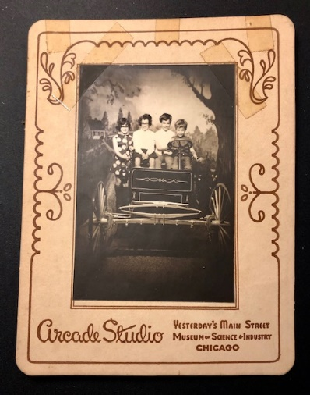

There is no date on this, but maybe it was taken during this trip.

Ruth is fine except that she doesn’t have as much energy as the other times; she admits that she is a few years older, ha! The Atlantic City trip was fine. The weather was excellent for going and coming back; however, we had 2 consecutive cold rainy days (Tues and Wed), which is not unusual for Atlantic City. I saw a lot of friends. My paper went OK on Mon morning. There were 6 of us from Pharmacology (half the department) and about 14 people overall from our Company. We all drove to the airport after Church the Sun I went. Ruth would have met me coming back but Andy had the Chicken Pox – he’s OK now. Hope you’re all OK and it has warmed up. Glad to have your letters.

**5-16-70 – Sat evening -** Dear Aunt Clara, Mother, M.J. and Bill, I called Mother Thurs night so I’ll write you first this time. I just don’t write as often as I used to, and I really don’t have any excuse. We hope you all got your flowers OK and your cards. We bought Ruth a pot of mums today; she will plant them later after we’ve enjoyed them in the house awhile. Ruth has been doing a fair amount of yard work. I mowed today and did some raking. The grass grows so fast now that it has to be mowed every week. This evening is very windy. There have been some storm warnings out for the Chicago area, but we’ve only had a few sprinkles in this area. We had quite a bit of rain several days ago. Mother said you’ve had quite a bit of warm weather so far. We were glad to have Mother’s letter today, and to hear all the latest news from Hutchinson. I imagine that your new minister of visitation is a young man. I had forgotten that Rev Hodges has 6 children.

Ruth is fine although she definitely doesn’t have the energy that she used to have. Maybe we’ll have a cool summer for her. The dates of our July trip to Kansas haven’t been finalized as yet. Last night we all went to the drive-in movie. It was “101 Dalmatians” and “The Family Band,” there are so few good family movies anymore that we don’t go very often anymore. Alan had baseball this morning. He is still quite excited about it so we’ll let him go as long as he wants to. They have had cold rainy weather for some of their practices. They practice some during the weekend then have their games on Sat. I guess they have 700-800 boys participating in Park Forest Little League. Wow! Park Forest has a lot recreational activities especially for younger kids. The swimming pool doesn’t open until June 16th.

Tomorrow is Ruth’s last day as choir director. The little ones (Cherubs) sing, and the older choir (Carol) sings an anthem with the adult choir. I don’t know whether they will try to hire a Jr. Choir director for next year or not. We missed adult choir practice last Thurs night since Lesle had a band concert. We had a treat afterwards and then called Mother when we got home. Last Wed night was the Science Fair. The kids had some projects but they waited until the last minute to do them. Last Sun afternoon I helped Alan and another boy go around to collect donations for Park Forest Boys Baseball; we have to go out again tomorrow for those who weren’t home last Sun.

Had an anniversary card from the Laidigs and they are as busy as ever. I guess you all know that the thing to do as you get older is to keep as busy as possible. Next Wed is my Session Meeting. Thurs is the Father Son Banquet, and Fri the Couples Club goes to a play in Chicago Heights. Hope you’re all feeling OK and you all had a nice Mothers Day.

**5-26-70 – Tues PM -** Its a beautiful evening here; Ruth and I are sitting quietly on the couch (this makes me happy), but outside there is a lot of noise from the neighborhood kids and their play. The sand pile has been worth every dollar we spent. Andy and his friends especially, and even the older kids, play quite a bit in the sand. The kids say they are all ready for school to be out. The Aqua Center doesn’t open until June 15th; its not usually warm enough until about that time of the year; it stays open then until Labor Day.

We still haven’t decided on the exact days for our Kansas trip. It may be a little later than I had said, since Alans baseball, and the kids Summer School things run through July. Alan is still enthusiastic about baseball and I guess he got to play a little more the last time. He has a game tomorrow night and Ruth and I will try to go for awhile. There is a Bible study group at Church afterwards that I may go to. Thurs night is choir practice.

I’ve started to teach one of the sixth grade Sunday School Classes at church. Its a small class of only 4-5 children (including Lesle) so it shouldn’t be so difficult for a starter. The kids will change classes on Sept 1st; our new curriculum starts at that time, but we won’t have Christian Education Sunday (I think we used to call it Rally Day?) until later in Sept. I have beside me the new (I think) American Baptist 5th and 6th grade monthly magazine. The girls have a real good friend down the block who is an American Baptist, and Lisa visited their church (its in Park Forest) one Sunday. In exchange, she is to visit our church sometime with Lisa.

Our church’s General Assembly is meeting this week in Chicago; I don’t know that we’ll get in for anything or not. One of the 12 official laymen delegates from all of the Chicago Presbytery is a member of our church. Last Wed night was Session Meeting for me; Thurs night was our Father-Son Banquet (we hope to have a Mother-Daughter Banquet next year). Another man and I took Alan and Andy. Each boy got a prize; there was a talk and a movie about the Indianapolis Race. On short notice I had to lead the singing.

Fri night the Couples Club went to see the play Gypsy presented by the Chicago Heights Drama Group. Talala School had their Pow Wow (Ruth worked some) and Alan had his baseball parade for opening day. Sat was cool and rainy and we stayed in some. Sun afternoon Ruth, another Lady and I took some of Ruths choir kids to a nearby amusement park. For the first time I slid down one of those big slides; I don’t believe this one is as tall as that one in Hutchinson. Alan had a game Sun afternoon also.

The Laidigs are busy and are not certain of their Summer schedule. Margaret Laidig (the 2nd oldest) is being married June 6th in New Jersey. Glad to have your “Thank You” letters and everything and hope it hasn’t been too hot for you.

**5-27-70 – Wed 6:30 PM -** Dear Aunt Clara, Mother, M.J. and Bill, I think its just about a week ago that I wrote to Hutchinson so I guess I’m getting better about writing again. The last couple of days here have been on the cooler side after a warm spell. It cools off nicely in the evenings after warming up during the day. Even though we’re quite a ways South of Chicago, we often get pollution in the atmosphere; the last few days, however, the air has been quite clean. I mowed the yard (it takes an hour) last Mon evening and it was cool.

Last night we went to the Jr. High School in Crete (the little town a few miles Southeast of us where the high school for our district is located) where Lisa’s band played, and where the 6-7-8th graders received their band and orchestra awards. Lisa and a boy were the only two 5th graders to earn the top award (about 35 in the band). Lesle received her band emblem (it made me think of the ones I received). The program was preceeded by a pot-luck supper. There was a big crowd. We do have a good music program in the schools. The girls may take summer band as well as another course or two. Alan is old enough to take something also.

Tonight I have to attend a Sunday School meeting at the church. I think I mentioned that I am trying my hand with one of the two sixth grade classes. Tomorrow night is choir practice. I have Fri off but the kids have to go to school since they had too many snow days last winter. Tomorrow is Andy’s last day of school. His class took a field trip to the zoo this week. We don’t have any big plans for the holiday weekend. We’ll probably try to catch up on some of the odd jobs around the house.

Alan has a game tomorrow night. They won their first game last Sat afternoon after losing their first two. He still seems quite interested and I imagine he will play out the season. Last Thurs night was choir practice. Friday night we all went to the drive-in movie. Sun was regular church. Alan had baseball practice in the afternoon. I planted a couple of little trees that Ruth had ordered. If the kids attend summer school and Alan plays the whole schedule of baseball we probably won’t leave for Kansas until about July 29 or 30th. We’ll try to spend a longer time in Kansas this year.

We’re considering the possibility of all taking the train to San Francisco the last week in August while I attend the Fall Pharmacology Meetings at Stanford University. It takes two days to go. We would go on Sat and Sun so I wouldn’t have to take any vacation time. The Laidigs won’t be home part of July so that is another reason we won’t go to Kansas as early as we had thought. Hope you’re all feeling perky these days and that it’s not too hot.

**6-15-70 – Mon PM -** I didn’t write sooner because of our phone conversation last week. We were glad to have M.J. call last Wed and to know that things had worked out for her to go to Madison to represent our family. (Our meeting with the consultant on Thurs went OK). As M.J. probably said I called Charles and Cooley Thurs night. M.J. was at her hotel so I told Charles to tell her when he picked her up Friday AM that Ruth could not go to see her at O’Hare since I was driving the car pool. It is terribly crowded at O’Hare and the parking is terrible because they are building a new larger parking lot.

Today was warmer and the kids played in the sprinkler after school. They get to wear any clothes they want to school today and tomorrow (their last full days); they get their cards on Wed. Alan has a ballgame on Wed and practice on Fri. They lost both of their games over the weekend (Sat AM and Sun night after church) and need practice. They are still learning to bat. He still seems to enjoy it. We go and sit on the bleachers and relax. Andy goes with us, and the girls most of the time. I think the girls spent most of their time walking around and buying junk food from the snack bar.

Ruth is substituting for the 4th graders next Sun and I’m having all the 6th graders while the other 6th grade teacher is on vacation for 6 weeks. He’ll be back while we’re gone later. Last Tues was the final Women’s Association Monthly Meeting until October. They had a pretty good crowd. I guess they usually have 25-40 at their monthly meetings. The baby was planned to fit in perfectly with the Association schedule since it will have arrived before the next meeting in Oct ha! Ruth is ready to relinquish her responsibilities as President.

Wed night had the program (music) at her evening circle. (She had her morning circle this AM). Two circles in one day! Last Thurs night I went with a minister to the Mission Council meeting up in Oak Lawn. We did not have a baby sitter anyway so Ruth stayed home from choir practice. The kids did not have piano lessons today (they will take some later), but do have oboe lessons next Wed. The girls are enrolled in summer school – art and music. They will not be able to go to all of Bible School because of that. Ruth again has the music at Bible School which starts a week from today.

The Aqua Center opens next Sat. Last Fri night we ate out. Alans game was Sat AM. Sat PM Ruth and I ate out (you can say your money covered it) to celebrate our Anniversary and then attended the very funny “Little Mary Sunshine” at Homewood-Flossmoor High School (a girl at Church sold us the tickets). It is a satire on Nelson Eddy and Jeanette McDonald and some of the early musical operettas you would remember. Hope you’re all OK. Again, we all thank M.J. for going.

**6-27-70 – Sat Noon -** Thanks for the nice Fathers Day card and gift. I guess we can say that I shared it with the family yesterday evening on the way home from Church when we all stopped at the Dairy Queen. Yesterday evening was the final Bible School program. It had to be held in the Social Hall since there was a wedding rehersal in the Sanctuary. Ruth as usual led the singing; she admitted she was getting tired by the end of the second week. They had a 140 or so (larger than last year) including a number of local Catholic children who always come because they don’t have anything similar at their church.

After the program we had a quartet practice; we’re singing at the July 12 service. Starting that Sunday and lasting through August, we’re trying an early Worship Service from 8:45-9:30 on a trial basis. I sing a solo tomorrow morning and the choir sings for the last time. Ruth now has a week to get ready for her weeks meeting at Purdue University. She and one other woman are the official representatives from our Womens Association. The meeting is the Triennial Meeting of United Presbyterian Women July 6-11. Mrs. Laidig will be there. I would imagine that some women from Hutchinson will be there.

After her meeting Ruth can relax until vacation time. We’ve been invited to stay at the Cormans in California while I’m at the meeting. If I can get approval we might go to Kansas the two weeks right before that; those are the last 3 weeks in Aug. One plan is to leave our car in Kansas and take the San Francisco Chief from Newton. This would save us some money. We can’t afford a new car before fall.

We slept late this AM since we didn’t have any place to go. We’ll have a late lunch and then Ruth has to go to the Church to help at a wedding reception. Alan has a game at 3:00 and then I must get something for s.s. class. Hope you and Aunt Clara had nice birthdays; I guess you’ve written some about them. Its been so cool and rainy the past week that the kids haven’t been swimming very much. They will probably get there tomorrow. Last Sat night was the steak fry for adults of the church sponsored by the adult s.s. class and the Couples Club. It was very successful with almost 50 people there; it was held at someones house. The Couples Club will sponsor a family picnic in July.

A week ago Fri was that trip to the Upjohn Labs in Kalamazoo. Everything went fine; left about 6:00 AM and got home about midnight. Alan is still enthusiastic about baseball. He fields better than he hits. He studies baseball books and knows more about it than I do. Alan is not going to Summer School like the girls. They all have piano lessons Mon. Ruth is lining up some potential piano pupils for Fall. She has to teach the Adult s.s. class a couple of Sundays in July. Again, hope you’re having a nice Summer. Any of you call us up sometime.

**7-16-70 – Wed PM -** Dear Aunt Clara, Mother, M.J. and Bill, We were glad to have your card so I’ll address this letter to you. Its been about 2 weeks since I’ve written to Hutchinson, but I did call Mother a week ago when Ruth was at Purdue for the triennial meeting of United Presbyterian Women. She had a good time although she naturally was tired. It wasn’t too hot or she would have been more tired. She had to walk quite a bit to get from one place to the other, and there was a lot of standing in line. There were about 5,000 women there. She met several women whom we had known at other places and churches. I believe she saw one of the Hutchinson women in passing. Kansas had one of the biggest delegations considering the size of the state. Ruth’s Mother was there from Oberlin, and she got to see her several times.

Ruth had her check-up today and everything is fine. The baby should arrive about the middle of Sept or a little before. We’ve about decided to not try to go to California that last week in Aug. We’ll be in Kansas sometime during the 2nd and 3rd weeks in August. We’ll let you know the exact dates later. It was cooler today after a hot humid spell. We put our old little air conditioner in the kitchen window so its not so bad for Ruth in the mornings (our kitchen is on the East). This summer has had some spells as hot as any of the other Summers we’ve been here. We moved here 4 yrs ago at a very hot time.

Our house is generally quite cool and its usually cool here at night. I know that you’re cool enough with your air conditioner. I played catch with Alan some this evening. He has 3 more games left. They have won 6 and lost 12. He still likes to play and I imagine he’ll play again next year. Ruth’s older brother John (17 years older) his wife Esther and their 3 youngest children (the 2 oldest are now married and the next one is in summer school) stopped here yesterday evening. They’re heading West on vacation. They camp and had pitched their tent at Joliet last night. We saw them last Summer at the Laidig’s Golden Wedding Anniversary.

The kids have one more week of summer school after this one; their concert is a week from tomorrow night. They all go swimming every afternoon if its warm enough. This Sat afternoon is Alan’s game and then a family church picnic in the evening. Our quartet went OK in Church last Sun AM. It was made up of Ruth, me, and two others whom we had never sung with before. (Both of my ballpoint pens gave out today.) (He writes in pencil from here to the end.) Hope you’re all OK and we’ll see you in August. We had a high school girl baby sit during the day while Ruth was at Purdue.

**7-28-70 – Tues PM -** Today was hot and humid again. Ruth and the kids went swimming this afternoon. I drove yesterday so they didn’t get to go. Our air conditioner (we put it in the kitchen window) has been a big help, especially for Ruth. Hope it hasn’t been too hot for you folks. The kids just cleaned the family room as I put the girls new box-springs on their beds. Ruth had been wanting them for some time. The girls do a pretty good job now of keeping their own rooms clean and neat. The boys are doing a little better; they have so many things in their room. Our room is the worst now; Ruth is gradually sorting things to make room for #5. I don’t know where #5 will go when he or she has outgrown our bedroom.

Ruth and the kids started to the pool yesterday evening but it started to rain and the pool was closed. I put a new honeysuckle bush in the ground. Tomorrow night I have a Christian education meeting and I guess there is not much else at night this week. I’m still teaching one of the 6th grade s.s. classes. I guess I’ve gotten a few things across. Last Sunday we went to the 8:45 church service and after s.s. came home to get ready to go to the Duvalls in a Northwest suburb. They have a backyard swimming pool and our 4 and their 4 youngest (they have 5 children) had a big time. We left for home about 7:30. It takes about an hour to drive up to their house.

Last Thurs and Sat Alan had his last two games. They won on Thurs and lost on Sat. I think Alan will play again next year but he was subdued (and didn’t feel too well) after the last game, partly because he didn’t do as well as he usually does. Thurs night was the girls band concert at the end of Summer School so Ruth went out there while I went with Alan (and Andy) to his game. The game was over early enough that I got to hear about half of the concert. There was a big crowd since they had a large Summer School enrollment. I think everyone was glad that Summer School and baseball are over since it seemed like we were busier than in the winter.

Mrs. L is going to the Williams Reunion in Ind the 2nd week in August so we will not go to Oberlin first. We’ll leave here Fri night Aug 7th and go to Indianapolis. Then on to Nashville and Memphis, Tenn and head towards Kansas. We’ll try to get to Hutchinson by Wed Aug 12th and stay through Church on Sun the 16th. We’ll then go to Oberlin and back home. What is Lucilles address and phone # in Tulsa. Norris is right isn’t it? but I can’t think of his first name. We might be coming through Tulsa and we could see them a minute. I guess the kids are satisfied that we’re not going to California. Thats a long ways from home when your baby is only a couple of weeks away.

**8-3-70 -** Mom writes a postcard. – Dear Mother, I’m not sure that Carroll will have time to write before we leave, so will drop you this card so you won’t look for us before dark on Wed the 12th. We’ll go through Kentucky, Tenn, Ark and a little of Oklahoma and I’m sure we won’t get into Kansas very early on the 12th. We’ll drive down and pick Carroll up at work on the 7th and go as far as Indianapolis that night. Lesle’s hoping for a lake to swim in somewhere along the way. We’ll see you the 12th.



In Oberlin. Cooler packed. Ready to head home. We can’t see Mom’s pregnant belly. Was that by design?

**8-23-70** – Mom writes another postcard. – Dear Mother, Just a note to let you know we got here about 10 PM Thursday so Carroll could go to work on Friday. We left my folks Wednesday about now and drove as far as Lincoln (we stopped at Pioneer Village in Minden and House of Yesteryear in Hastings). Thursday our only sightseeing was at Herbert Hoover’s birthplace. We finally got Alan’s birthday telescope today (there was a mix up on an order and then the one we wanted wasn’t available) so he and Carroll tried to check the sky tonight. Andy still has some infection, but we’re watching it.

**8-30-70 – Sun -** It’s been a hot Sunday, but enough of a breeze to make it bearable. We didn’t get up in time to go to the early service, but there was a good breeze across the front of the Church where we sat. It is often fairly warm here through Sept. Today was the last of 2 services on Sun AM. The Session will decide later if we will have more; we have never had 2 services on a regular basis.

My boss went to that California meeting last week. He was back on Fri. We should know in about a month what the overall research budget will be; we may have to make some changes in what we’re doing. The union at work (production etc.) may strike on Tues. If so, some of the salaried people may have to go help in production.

Ruth just finished making a nightgown (she will make another one) and is gradually getting everything ready to go to the hospital, etc. We’re still sorting and cleaning, and are rearranging our bedroom to make more room for #5. Some of the area schools start this week, but ours doesn’t start until next week. Lesle will ride the bus out to the Jr. High at Crete. All the other kids will be over here at Talala; they walk about 2-3 blocks. I guess their music lessons will start in a week or so. Ruth enrolled them all last week.

Ruth has a Women’s Association Board Meeting Tues, and then will be pretty much free (to have the baby) until the Women’s Retreat the first part of October. The Laidigs will probably come sometime in October. Mr. Laidig still works a lot at the Oberlin Museum (we always visit it) and is active in both of the Highway Associations of the Federal highways (83 & 36) which go through Oberlin. We went to the rodeo while in Oberlin and Grandpa took the kids out to the junk yard. We loved to go to the junk yard, and always rode in the back of his pickup truck holding on to the sides for dear life.

I just stopped to go get the baby basket and holder down from over the car port. Ruth will repaint it and fix a new lining. We’ve loaned it out a time or two. M.J. and I, Johnny, our children, and I think Jimmy and Jana Kay all have used it, so I guess it will have to be preserved within the family. Choir practice started last Thurs night although the choir won’t sing until next Sun. Our family has enjoyed sitting together in Churchs this Summer. I had a s.s. meeting last Mon night. We still need Jr. and Jr. High teachers. As of now I’ll continue on with a 6th grade class. We change classes next Sun and start using a new curriculum.

On the way back from Oberlin we stopped at Pioneer Village (we’ve stopped there once before) and at the Hastings, Neb Museum. We had a motel at Lincoln and then drove on on Thurs. We stopped at the Herbert Hoover birthplace and museum in West Bend, Iowa. Thanks again to everybody in Hutchinson for everything (the kids all have the turtles on their shelves). We felt we had one of our best vacations. Grandmother underlined the last sentence.

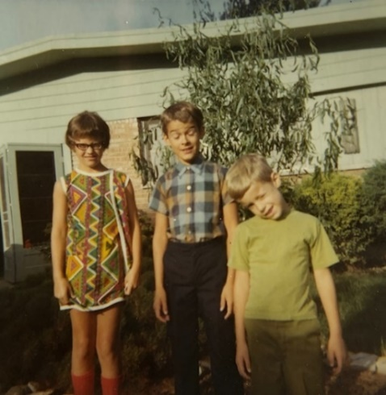 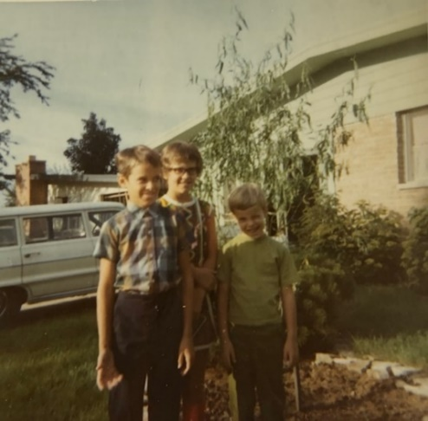

First day of school 1970. I guess Lesle was already gone on the bus to her first day of Junior High.

**9-12-70 – Sat -** Dear Aunt Clara, Mother, M.J. and Bill, I’ll send the letter to you first since I just mailed an envelope to Mother containing a magazine discussing the relationship between Armour and Greyhound. I don’t know whether I ever told you folks that Armour and Company is now owned by Greyhound (buses, eating places, etc.). It hasn’t had any great effect on us so far.

I just got back from taking Lisa, Lesle and 5 of their friends bowling. It was Lisa’s birthday party. We had Lisa’s birthday dinner last Wed. The girls are having their refreshments in the kitchen at this time. I’ll take them home in a little bit.

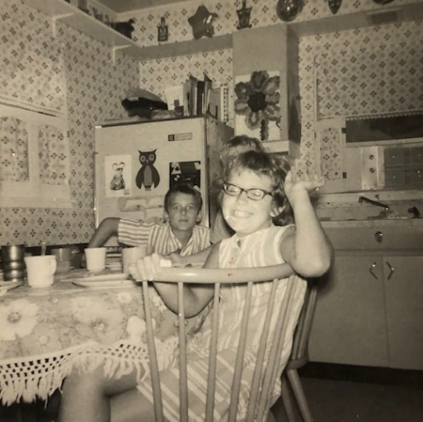 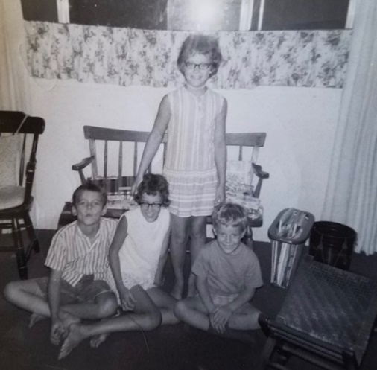

More pictures of Lisa’s birthday - number 11 this year.

It rained earlier today, but has cleared off at the present. It’s been cooler and like fall the last few days. I mowed part of the grass this AM. We’ll be at home tonight. I’ll have to work on my s.s. lesson. That’s nice that M.J. & Bill are now helping in s.s. We still need one or two more teachers. Tomorrow afternoon is the Junior High Youth Fellowship. I don’t know whether Lesle will want to go or not. I think I know ☺

I thought Ruth might go to the hospital last week, but it was a false alarm. Everything is all ready, and Lisa’s birthday things are over with so we’re ready to have it over with. The kids are all started in school OK. Lesle rides the bus and has to leave about the time I do. I went to Washington D.C. a week ago last Thurs for a short meeting at the Food and Drug Administration regarding the testing of one of our drugs (it doesn’t work in man so it is being “dropped”). I went with 2 other men. We went Wed PM and came back Thurs afternoon. The only other time I had been to Washington was about 3 yrs ago when we all drove East and I attended a Pharmacology Meeting at Howard University in Washington, D.C. I had a nice night view of the Capitol and Washington Monument just before we landed.

I had Session meeting last Wed night (I go off the end of this year). We stayed home from choir practice Thurs night because we both were tired. Last night we all ate at a new restaurant where we had not been before. After that the girls slept out in a makeshift tent in our neighbors backyard (with 2 or 3 other girls). It is supposed to get down to about 50 tonight. Last Sat afternoon we picked up a coffee cake that an 86 yr old lady at Church wanted to make for us. She reminds me of you and Mother – senior citizens who have a great religious faith and a zest for living – keep it up. I guess it’s been almost 2 wks since I wrote. I guess most of the time we’ve been cleaning, sorting and getting ready for the baby. We’ve rearranged our bedroom to make room for the baby. The baby basket has been repainted. Hope you’re all OK.

**9-26-70 – Sat AM -** I haven’t written to Hutchinson for about 2 weeks, but, as usual, I meant to write earlier. It is cloudy and rainy this AM and we’re all staying in except that the kids all went outside for awhile. I haven’t heard too many complaints about school so I guess everything is OK. Lesle has gotten used to her bus schedule; she has to get up a little bit earlier than before. The kids are all back taking their piano lessons. All 4 of them go at the same time. The girls private oboe lessons will start sometime in Oct. There are 3 oboes in the Jr. High Band, and since they don’t carry and play their oboes while marching (the double reeds might jab up into your mouth), they have the job of carrying the flag and banner at the front of the band. Mon night Jr. High parents are to visit the school.

Andy is beginning to read a few words, and I think enjoys school. He has a black woman teacher but has never said one word about her race, and we’ve never said one word to him. I had two night Church meetings Tues (Benevolence Committee) and Wed (Budget Committee). As with most churches, money is getting tighter and harder to raise. Thurs night I stayed home and Ruth went to regular choir practice (I haven’t been for 3 weeks), and then rehearsed (the ‘a’ was added in later ☺) her Womens Chorus for the Women’s Association Retreat on Oct 6. We had figured that the baby would be here by now so Ruth would have plenty of time to get ready. Since she’ll be in the hospital about 5 days it could be that she’ll have to miss it, which would be too bad.

This past week at work we found out about our new research directions. The type of work I’ve been doing for 8½ years in industry is being dropped, except for additional work on 2 or 3 things that still look promising. I still have a job but will have to work on other things. Some of this will be more akin to pharmacy so I’m looking forward to it. Three of the bottom people in Pharmacology were let go, and the position of a 4th will probably close when he retires in a year. There were 12 in the Department so we’ll be down to 9. Two of them (not Pete) are in our car pool, and all 3 of them were working with me. They were hoping for a budget that would keep everybody until the government began to crack down on that drug I told you about; its sales will probably go down and it is a big profit item. Probably for the best if it “doesn’t work in man.”

Last Sat AM Ruth and I went to the Park Forest Art Fair. We bought a humorous General on a Hobby Horse to hang in the family room. Before long we hope to get carpeting for the family room. Thanks for the birthday card and gift. I got some of the new ties, a new shirt and 2 new trousers. Glad to have your letter and hope everything is OK.

**9-28-70 – Alec is born!** He weighed 7 lbs 5 oz and was 20” long. According to Mom he was born at “2 something AM.”

**10-22-70 - Thurs PM -** I can’t remember when I last wrote to Hutchinson. It was nice talking to you the other night. Tonight it is supposed to get below freezing, so it will probably be our coldest night of the fall. I believe temperatures have tended to be slightly higher than normal so far this fall. That day I called you I heard over the news about the colder weather and snow out in the Midwest, Colorado, etc.

Alec and Andy are here in the family room with me. Ruth just fed Alec so he should stay satisfied while Ruth goes to choir practice for the first time since he was born. I haven’t been for 5 or 6 weeks – the longest I think I’ve ever missed. Ruth will sing in the choir Sunday while I watch Alec. We won’t put Alec in the nursery for 2 or 3 Sundays yet. He’s had sniffles and a lot of mucus so far. Right this minute Alec seems to be noticing us as much as he ever has. He is gradually going longer between feedings – about 2½-4 hrs now, and he usually stays awake awhile after he eats. I fed him from a bottle one night while Ruth attended her womens chorus (Chanconets) practice. He’s only had a bottle 1 or 2 other times. Lesle and Lisa are learning to take care of Alec.

We don’t know when the Laidigs are coming. (No one ever seems to know when the Laidigs are coming.) They are presumably now in Arkansas (Ozarks) at some place where they are trying to sell land or houses or something. They plan to drive on up here afterwards. They will have to sleep in the family room since Lisa now has the room where they used to sleep. We plan to have the family room carpeted before long. The floor gets cold in the winter and Alec will need a place to play thats warm. The older kids can build on the floor, etc. Our family room has sure worked out well in this house.

Sat night is bowling with the Couples Club at Church so we may try to go. It’ll be the first time to hire a baby sitter for Alec. Lesle seems to doing fine in Jr. High. I think she’s more outgoing now. I don’t believe she’s as shy as I was. Of course she has more brothers and sisters. She could do better in school if she would work at it. I think she is like I was, she does just enough to get by. The girls haven’t started any oboe lessons as yet. Ruth stayed home from Church last Sun but made it the first Sunday (World-Wide Communion) with Alec. She stayed in the narthex with Alec. We’ll have Alec baptized the Sun the Laidigs are here. Last night I went to a Church meeting about Mission and giving. I have a job for the coming year if sales are good, but I’ll be watching for various possibilities. I’ll tell you more about that later.

**10-26-70 – Mon PM -** I’ll try to get this written so Ruth can mail it when she goes out to her chorus rehersal later. I believe they sing somewhere next Mon night. She did not sing with them the first time they had an appearance. The Laidigs came last Fri and I guess they plan to leave tomorrow. We’re trying to talk them into staying another day. They came up here after visiting the relatives in Indiana. Before that they had been in Arkansas, in the Ozarks, visiting a resort place where the developers are selling lots, etc. They bought a place but will just plan to keep it for an investment. I don’t think they plan to move there ever. They owned a house down in the valley (Texas) for awhile but just rented it.

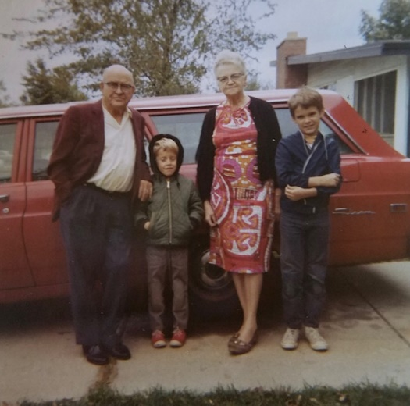 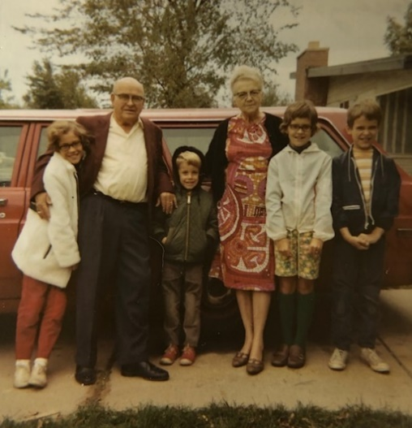

These pictures are labeled “Spring 1970”, but there is no mention of the Laidigs visiting then. So maybe they go here, since we know they were in Park Forest in October. The red station wagon is theirs.

Mrs. Laidig has helped Ruth on starting the kids Halloween costumes. Lesle has a serpent (from the Bible) costume which she wore to the Jr. High Fellowship Church party last Sat. night at the Church. She carried an apple and won the prize for best costume. We didn’t feel so rushed last Sun AM because of the change back to Central Standard Time. I took the kids and Mr. L. to s.s. (he went up to the adult class). Ruth, Alec and her Mother came later to church. Alec’s baptism went off OK. Mr. L. and I were the two elders. I held Alec and the other 4 children came up front with us. Alec was good but shortly afterward he seemed like he would get fussy so she took him out. I stayed in the pew. It was only about the 2nd time in our Church that I had been in the audience when our choir sang. After church we stopped at Kentucky Fried Chicken and brought our lunch home. We stayed home the rest of the day resting, reading, etc.

Alec has his one month check-up tomorrow. He seems fine except for some infection under his diaper. I hope the Dr. gives him something tomorrow to help get it healed. Tomorrow night Lesle has a concert. Wed night I have a committee meeting at church. Thurs night is a dinner in Kankakee honoring the 3 people in our Department who are being terminated the end of this week. None of them have jobs as yet. Next Sat afternoon the Jr. Department at Church will have a Halloween party from 1:30-3:30. Alan and Lisa are in that Depart. Another man and I are in charge of the games. Last Wed night was the congregational dinner at Church at which the 1971 budget was presented. I went for the business meeting and Ruth stayed home. Thurs night I went to choir practice for the first time in 5-6 weeks. Fri night the Laidigs were here. John and Esther Laidig were also here for supper. He had a meeting Fri AM in the area and Esther came along. They are the ones in New Jersey. So it was a nice get together. Glad to hear the news from Hutchinson and to know that you’re all OK.

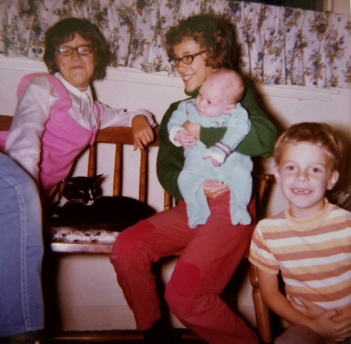

Alec with siblings – 1 month old.

**11-4-70 – Wed PM -** Ruth wrote her folks today, so I’ll do the same. We had a letter from the Laidigs today stating that they had arrived home safely. They started home a week ago yesterday morning about the time there was snow in the Midwest. They had some rain and fog when they started out, but didn’t have any trouble after that. Last week I believe Ruth told you that Alec had a test for skin infection. It turned out to be a fungus which is now slowly responding to treatment. He’s had some other skin infections also, but is better. Last Thurs night was the dinner honoring the 3 people in our Dept. who were terminated. We had a baby sitter and got there late (it was in Kankakee) as we expected. The 3 people received nice gifts, two tape recorders and a nice clock radio. Last Friday was their last day.

Alec watches things now and smiles some. He likes his green wall by his changing table the best. I can’t get him to smile for me. He’ll lie on his back awhile now and entertain himself. Last Sat was a “wild one.” Lesle had a parade. I got a few tricks ready for the Jr. Dept. party from 1:30-3:30. Lesle wore her last years Puff-n-Stuff (TV Childrens show character) costume over to the Plaza and a Jaycee sponsered contest; she won second place so will probably have her name in the paper. The kids then had their trick and treating. In the evening I had to get my s.s. lesson.

Because of his skin problems Ruth has kept Alec in and has not taken him to Church on Sunday since he was baptized. Last Sun afternoon Lesle had her regular fellowship; she had to take refreshments. Mon night Ruth’s singing group had an appearance at a local church. Last night Ruth had a church meeting. I baby sat both nights. Tonight we have to go over to the School to the open-house – PTA sponsored. I suppose you watched the election results on TV last night. I watched part of the evening. Nixon won, of course.

Ruth will probably attend choir practice tomorrow night. This Sun afternoon is our Churchs Every Member Canvas. We’re having a man at work and his family up for Thanksgiving dinner. They live in Kankakee. He is planning to relocate if he can. He is the chemist I have worked closely with. I’m still holding tight waiting to see how things develop during the coming months. Jobs are very scarce now unlike a few yrs ago when I was looking and had several quick possibilities.

We’re enjoying our new carpet in the family room – now I’ll have to get it paid for. I can’t think of any more news. Hope you’re all OK. It has felt like winter the last few days. I have to drive more now since we lost two members of our car pool.

**11-21-70 – Sat Afternoon -** I’m watching the big Michigan, Ohio State football game. Alec is asleep in his swing (you wind it up and it swings the baby back and forth). Ruth just took the older kids to Childrens Theater, and then she will go to the store for groceries. I went last week and went several times before Alec was born. Alec has had solid food a few times. A babys expression when he first tastes solid food is always fun to watch. Alec’s skin problems have pretty well cleared up. I expect that he weighs about 9 lbs now. We stayed home last night, but last Thurs night the whole family went to Church for the Spaghetti Dinner sponsored by the Senior High Fellowship as a means of raising money for their annual retreat. Afterwards we all stayed and Ruth and I went to choir practice. The kids helped watch Alec. It was the first time in many weeks that Ruth and I had both been at choir practice at the same time.

Thanks for the Thanksgiving money. Ruth is buying the turkey this afternoon. As I think I wrote in the last letter we’re having some people from Kankakee up for Thanksgiving dinner. They are the Hughes; he is a chemist that I have worked very closely with ever since I’ve been at Armour. They have 2 children and the wives have never met each other.

We were glad to have your letter, also. (I’ve had to take a break to take care of Alec. Ruth and the kids are home now.) I guess I didn’t hear that you had an ice storm in Hutchinson; they can be bad. We’ve had just a little bit of snow so far, but its been getting colder all the time. We don’t usually have much snow here until later in December or early Jan. It usually stays fairly cold into March.

When I called Mother she said that you all had looked at Leila’s trip pictures. Thats nice that Leila has been able to take all the trips that she worked hard for. Ruth is still going to her womens singing group on Mon night; I have been doing the baby sitting while she goes. I have both Thurs (Thanksgiving) and Fri off next week – I don’t know what we’ll do on Fri.

We’ll be thinking about you all on Thanksgiving. I haven’t written for a couple of weeks, I guess, and I can’t remember every thing we’ve done. Last Sun afternoon Ruth and I went to Kankakee to the Community Concert. The program was Fred Waring and his Pennsylvanians. They sing, dance and play instruments, and put on a show that appeals to all ages. Fred Waring is now 70 years old, but still directs the entire show. And some 72 year olds build treehouses ☺ I had never seen him before, but I remember listening to him over the radio when I was a boy. After the concert we ate out. We had a baby sitter, of course. Alec is smiling more all the time. We don’t know our Christmas plans, as yet, but will let you all know. Hope you’re all OK.

**12-?-70 – Sun PM 7:00 -** It was nice talking to you last night; I’m sorry I didn’t write earlier. It just doesn’t seem like it should be time for Christmas. We got the Christmas boxes down last night, although they haven’t been unpacked since we won’t get our tree until next weekend. The kids were all very excited and I can remember how excited I used to be when getting out many of the same things year after year. The kids have been making Christmas things for some time now. Ruth hasn’t started her cards yet, so I don’t know whether she’ll have time to make them or not.

The adult choir is singing the “Christmas Oratorio” by Saint-Saens next Sun AM for the worship service. Its the same one I sang in Hutchinson when I was in Junior College (1949). I think we also did it at the morning worship service. Last Thurs night I attended a special meeting while Ruth and the kids went to regular choir practice. We stayed at home Fri night; I brought supper in. Yesterday was the usual Sat with shopping, errands, etc. I picked up a $74 Christmas order at Penneys.

This morning a man came and gave a chalk talk for the Primary and Junior Depts. The kids all enjoyed it. The man was from another church and donated his services. This afternoon Lesle had her Jr. High Fellowship. As I said over the phone things at work seem a wee bit better for me, so I’m not going to do anything for now. I’ll see how things are in the Spring. I did answer one advertisement that someone noted for me, but the position had already been filled.

The girls haven’t had many oboe lessons since their teacher is on a school board which has had a lot of extra meetings because of trouble at one of the schools. Haven’t heard recently from the Laidigs, but guess the’re OK. I don’t know where they plan to spend Christmas. I guess we’ll try to get to Hutchinson for a couple of days after Christmas like we did last year. I think the El Capitan and San Francisco Chief are running the same as last year. I believe they were talking about a strike like last year, but I haven’t heard any more. Are M.J. & Bill planning to go somewhere after Christmas? As I said over the phone our friends couldn’t make it on Thanksgiving because their daughter was sick. I don’t know when they will get up. We attended Thanksgiving service at our Church that AM and then enjoyed our meal by ourselves. We had a nice relaxing vacation. We all went bowling that Friday. Hope you’re all OK.

**12-14-70 – Mon PM 7:00 -** I’ll start this tonight but I don’t know whether I’ll get it finished before Ruth leaves for her singing group rehersal. She missed a week ago tonight because I had a touch of the flu; I stayed home from work all day last Mon and Tues AM. I went back Tues afternoon after lunch. I didn’t feel too badly, just a little tired and ran a fever of about 100 F. Last Tues AM the singing group met at our house for practice; I stayed back in the bedroom.

Last Wed night I had Session meeting at the church. I have one more meeting in Jan and then my 3 yr term will be finished. I’ve learned a lot, although I probably haven’t worked as hard as I should have. Ruth has now finished her two year term as President of the Womens Association.

Thurs – I held this letter off since Ruth had just written your Christmas card. As usual I’m late getting my presents so will have to do it this weekend. I’ll need to get some for my s.s. class also. Ruth has everything about done except for the cards. The kids have been making things for quite some time. They’re very good at thinking about others at Christmas time. We got our tree last Sat. We went out to the tree farm where we went a year ago and picked it out while it was still in the ground. It was very muddy and Ruth carried Alec. We stopped at a restaurant on the way and ate our lunch.

Last Sun was the “Christmas Oratorio” which went off OK. I had a small solo part; Ruth had more. We have two other bass soloists now so they don’t have to call on me as much. I’ll enclose an article about Ruth’s singing group, the Chansonettes; it is sponsored by the Park Forest Recreation Commission. Their smaller singing groups, a sextet and a triple trio, sang twice yesterday, and Ruth directed once. She is going out again tonight to sing for the last time until after the holidays. Ruth had rehersal Mon night so she’s been busy. We’re missing choir practice tonight. This Sun afternoon is the annual s.s Christmas Program at Church followed by a supper. They finally got a director at Church for the Youth Choir and I believe they will sing this Sunday. We’ve had some snow but haven’t had any slick roads as yet. We usually have our first light snows about this time.

We’ll take the San Francisco Chief on Sat leaving here (Joliet) at 10:50 in the morning at arriving at Newton at 10:50 in the evening. Thats the same train as last year. I’m sorry but we can only stay Sun and will come back on Mon on the same train leaving Newton Mon AM at 7:40. I saved 1 day vacation from last Summer and that will be Mon. I hate to ask for an extra day off with my current boss. Let us know if Bill can’t pick us up and I’ll make arrangements for a rental car. Love, Carroll & family

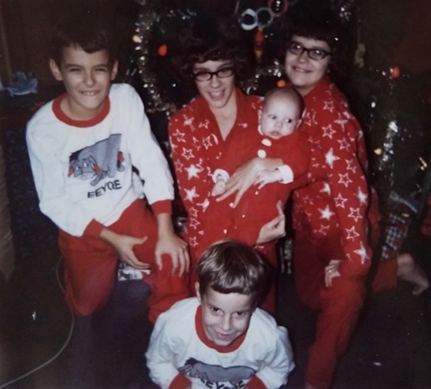 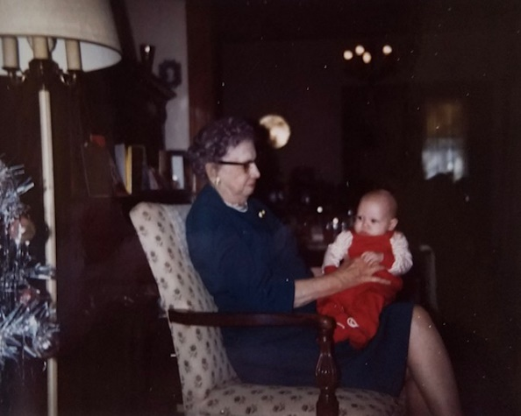

Christmas pajamas in Park Forest. And Aunt Clara holding 3 month old Alec in Hutchinson.